Exp No. 14: 5G Throughput vs SNR with Modulation Labels

AIM:
To simulate the performance of a 5G wireless communication system using MATLAB
by analyzing the relationship between Throughput (Mbps), Signal-to-Noise Ratio (SNR) (dB), and different Modulation Schemes (QPSK, 16-QAM, 64-QAM, and 256-QAM).
Objective:
1. To evaluate the Throughput (Mbps) of a 5G communication system under different
Signal-to-Noise Ratio (SNR) conditions.
2. To analyze the effect of Signal-to-Noise Ratio (SNR) (dB) on the performance and
reliability of the 5G communication system.
3. To compare the performance of different Modulation Schemes (QPSK, 16-QAM, 64-
QAM, and 256-QAM) and determine their suitability for varying SNR conditions.
Procedure
1. Define the simulation parameters such as SNR range, bandwidth, modulation schemes
(QPSK, 16-QAM, 64-QAM, and 256-QAM), and transmission settings.
2. Generate random binary data and modulate it using the selected modulation schemes.
3. Simulate the transmission of the modulated signals through an Additive White Gaussian
Noise (AWGN) channel with different SNR values.
4. Calculate the Throughput (Mbps) achieved for each modulation scheme at different
SNR levels.
5. Analyze the impact of Signal-to-Noise Ratio (SNR) on communication performance and
throughput.
6. Compare the performance of QPSK, 16-QAM, 64-QAM, and 256-QAM under identical
channel conditions.
7. Plot MATLAB graphs for Throughput vs SNR and SNR vs Modulation Scheme to
visualize the system performance.
8. Interpret the results to identify the most suitable modulation scheme for different SNR
conditions in a 5G communication system.

Objective 1 Matlab Code and Output:
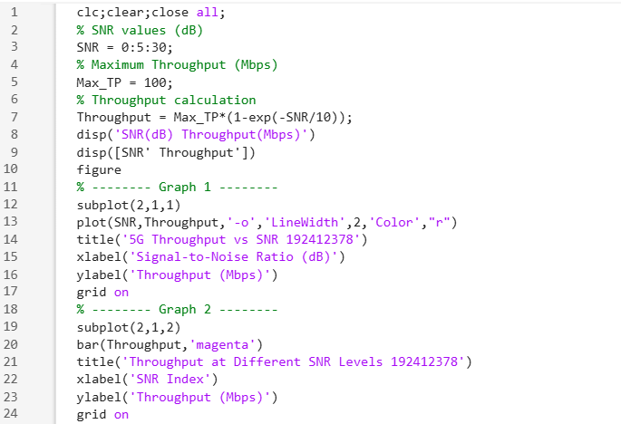
OUTPUT:
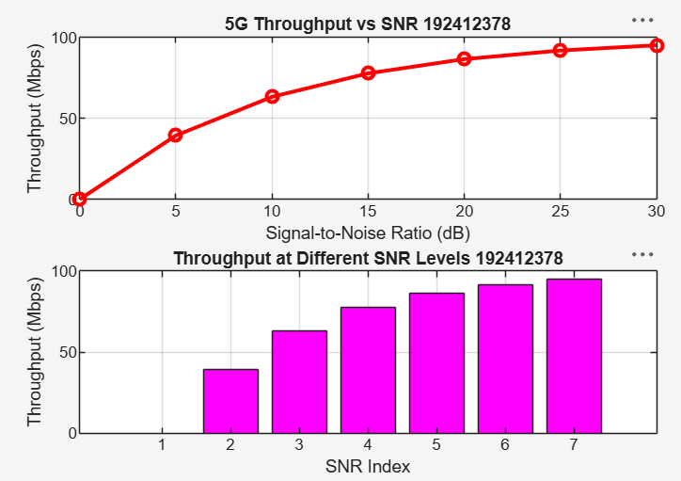

• The throughput of the 5G system increases as the SNR increases due to improved signal
quality.
• Higher SNR enables efficient data transmission, resulting in greater throughput and better
communication performance
Objective 2 Matlab Code and Output:
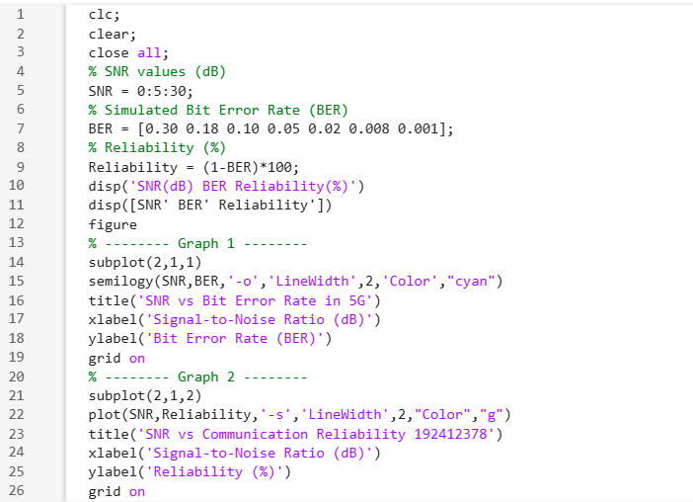
OUTPUT:
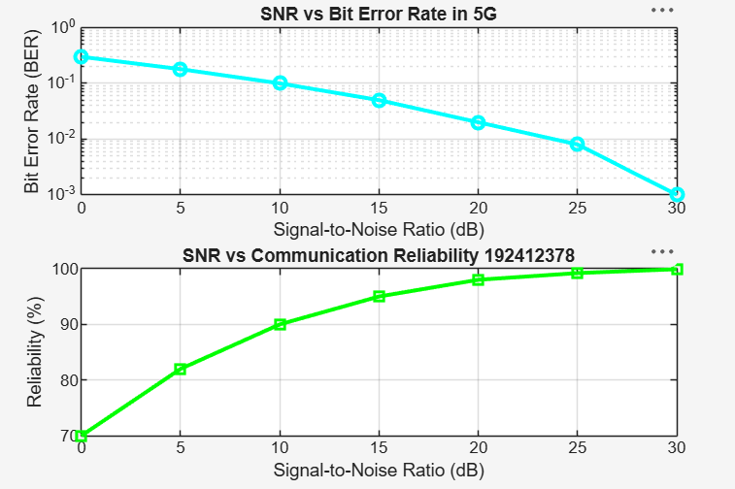
• As the Signal-to-Noise Ratio (SNR) increases, the Bit Error Rate (BER) decreases,
resulting in more reliable communication.
• Higher SNR improves the quality of the received signal, thereby enhancing the overall
performance of the 5G communication system.
Objective 3 Matlab Code and Output:
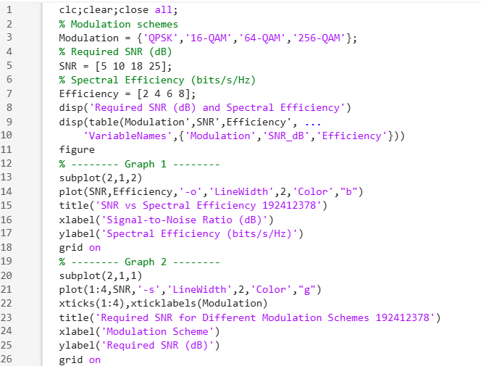
OUTPUT:
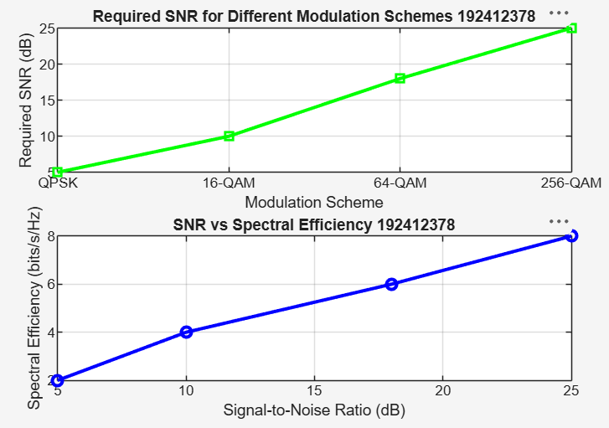

Result:
1.The Throughput (Mbps) of the 5G communication system increased with increasing
Signal-to-Noise Ratio (SNR), demonstrating improved data transmission performance.
2.The simulation showed that higher SNR (dB) reduced transmission errors and enhanced
the reliability and quality of 5G communication.
3.The comparison of QPSK, 16-QAM, 64-QAM, and 256-QAM revealed that higher-
order modulation schemes achieved greater throughput and spectral efficiency but
required higher SNR for reliable communication.

